Ex no: 12 | Developing a webpage using javascript
Date : | Developing a webpage using javascript

Question:1
Write a JavaScript function to find the sum of first n odd numbers and display the Result:.Get the
value of n from the user

Aim::
To Write a JavaScript function to find the sum of first n odd numbers and display the Result:.Get the
value of n from the user

Code::
<html>
<head>
<link rel="stylesheet" type="text/css" href="c.css">
</head>
<body>
<h2>The sum of n odd numbers</h2>
<script>
var n = Number(prompt("Enter N"));
add(n);
function add(n){
var i=0;
var n1=n;
var sum=0;
for(i=1;i<=n1;i++){
if(i%2!=0){
sum=sum+i;}}
document.write("n: ",n);
document.write("<br>sum: ",sum);}
</script>
</body>
</html>
Output
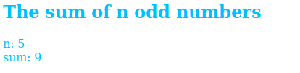

Result:
Hence we successfully solved above probleem and the output verified
Ex no: 12 | Developing a webpage using javascript
Date : | Developing a webpage using javascript

Question:2
Write a JavaScript function that checks occurence of substring in a given string

Aim:
To Write a JavaScript function that checks occurence of substring in a given string

Code:
<html>
<body>
<script>
var s=prompt("Enter string");
var s1=prompt("Enter substring");
if(s.search(s1)==0)
document.write("substring ",s1," is present in string ",s);
else
document.write("substring ",s1," is not present in string ",s);
</script>
</body>
</html>

Output
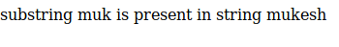

Result:
Hence we successfully solved above probleem and the output verified

Ex no: 12 | Developing a webpage using javascript
Date : | Developing a webpage using javascript

Question:3
Write a JavaScript function that accepts a string as a parameter and converts the first letter of
each word of the string in upper case

Aim:
To Write a JavaScript function that accepts a string as a parameter and converts the first letter of
each word of the string in upper case

Code:
<html>
<body>
<script>
function uppercase(str)
{
var arr = str.split(' ');
var arr1 = [];

for(var x = 0; x < arr.length; x++){
arr1.push(arr[x].charAt(0).toUpperCase()+arr[x].slice(1));
}
return arr1.join(' ');
}
a=prompt("ENter String to change");
document.write("given string is ",a,"<br>",uppercase(a));
</script>
</body>
</head>
Output:
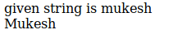

Result:
Hence we successfully solved above probleem and the output verified
Ex no: 13 | Developing a webpage using javascript
Date : | Developing a webpage using javascript

Question:1
Write a JavaScript program that displays the position of the first occurrence of "World" in the
variable txt

Aim:
To Write a JavaScript program that displays the position of the first occurrence of "World" in the
variable txt

Code:
<html>
<body>
<script>
a=prompt("ENter String ");
b=prompt("ENter String for inddex check");
var n = a.indexOf(b);
document.write(n);
</script>
</body>
</head>

Output

Result:
Hence we successfully solved above probleem and the output verified

Ex no: 13 | Developing a webpage using javascript
Date : | Developing a webpage using javascript

Question:2
Write a JavaScript function to remove specified number of characters from a string

Aim:
To Write a JavaScript function to remove specified number of characters from a string

Code:
<script>
function rem(str, char_pos)
{
a = str.substring(0,str.length-char_pos);
return a;
}
b=prompt("Enter string");
document.write(rem(b,3))
</script>
Output

Result:
Hence we successfully solved above probleem and the output verified
Ex no: 13 | Developing a webpage using javascript
Date : | Developing a webpage using javascript

Question:3
Create an HTML page with a textbox and a command button:When the user gives a number and presses the Calculate button, it has to alert the sum.

Aim:
To Create an HTML page with a textbox and a command button:When the user gives a number and presses the Calculate button, it has to alert the sum.

Code:
<html>
<head>
<script>
function fun(){
var n=document.getElementById("#").value;
var d=n.split('');
var sum=0;
for(i=0;i<d.length;i++){
sum=sum+Number(d[i]);]
alert(sum);]
</script>
<body>
<form>
<p>Text Box <input type="text" id="#" placeholder="Enter someting">
<button type="button" onclick="fun()">Click Here!</button>
</form>

Output
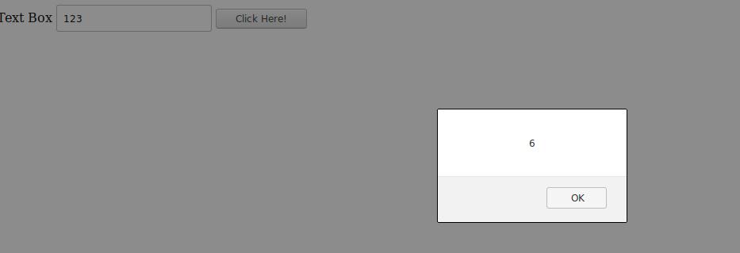

Result:
Hence we successfully solved above probleem and the output verified
Ex no: 14 | Developing a webpage using Regular Expression
Date : | Developing a webpage using Regular Expression

Question:1
Write a JavaScript program to check an Aadhar number(Format :9999-9999-9999)

Aim:
To Write a JavaScript program to check an Aadhar number(Format :9999-9999-9999)

Code:
<html>
<head>
<script type="text/javascript">
a=prompt("Enter aadhar nos");
is(a);
function is(str){
var creditPattern = /^\d{4}-\d{4}-\d{4}$/;
if (creditPattern.test(str)){
alert("Correct");}
else{
alert("Incorrect format");}}
</script>
</head>
Output:

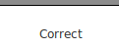

Result:
Hence we successfully solved above probleem and the output verified
Ex no: 14 | Developing a webpage using Regular Expression
Date : | Developing a webpage using Regular Expression

Question:2
Write a JavaScript function that checks occurence of substring in a given string

Aim:
To Write a JavaScript function that checks occurence of substring in a given string

Code:
<html>
<head>
<script>
function validate(email,ph){
var email=document.getElementById("mk").value;
var ph=document.getElementById("mk1").value;
var emailp = /^[a-zA-Z0-9._-]+@[a-zA-Z0-9.-]+\.[a-zA-Z]{2,4}$/;
var phone = /^\d{10}$/;
if(emailp.test(email)==1 && phone.test(ph)==1)
alert("Email and Phone Number are correct format");
else
alert("In Correct");}
</script>
</head>
<body>
<form>
<p>Email:<input type="text" id="mk" placeholder="Enter Email">
<p>Phone Number:<input type="text" id="mk1" placeholder="Enter phone number">
<button type="button" onclick="validate()">Click Here!!!</button>
</body>
</html>

Output

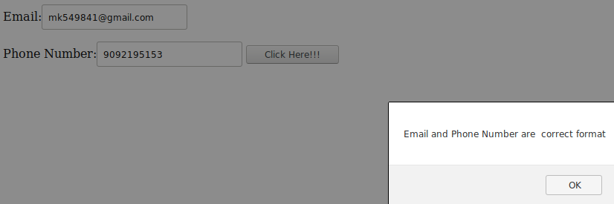

Result:
Hence we successfully solved above probleem and the output verified

Ex no: 15 | Creating XML document for given data
Date : | Creating XML document for given data

Question:1
Create XML document for the following data: Student Registration Form Name Rahul Age 16 Gender Male Course C Programming

Aim:
To Create XML document for the following data: Student Registration Form Name Rahul Age 16 Gender Male Course C Programming

Code:
<<?xml version="1.0" ?>
<StudentRegistrationForm>
<name>Rahul</name>
<Age>"16></Age>
<Gender>Male</Gender>
<Course>C Programming</Course>
</StudentRegistrationForm>
</html>

Output

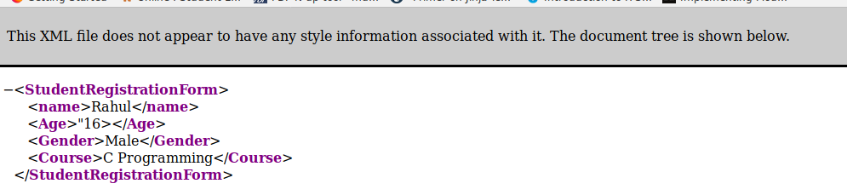

Result:
Hence we successfully solved above probleem and the output verified
Ex no: 15 | Creating XML document for given data
Date : | Creating XML document for given data

Question:2
Check whether the following XML documents are well formed. If it is not well formed, correct the errors. <?xml version="1.0" encoding="iso-8859-1"?> <message> <email> <header> <sender>me@wipro.com</sender> <recipient>you@wipro.com</recipient> </header> <subject>Re: XML </subject> <text>I'm working on XML now. </email> </Messag

Aim:
To Check whether the following XML documents are well formed

Code:
<<?xml version="1.0" encoding="iso-8859-1"?>
<message>
<email>
<header>
<sender>me@wipro.com</sender>
<recipient>you@wipro.com</recipient>
</header>
<subject>Re: XML </subject>
<text>I'm working on XML now.</text>
</email>
</message>

Output

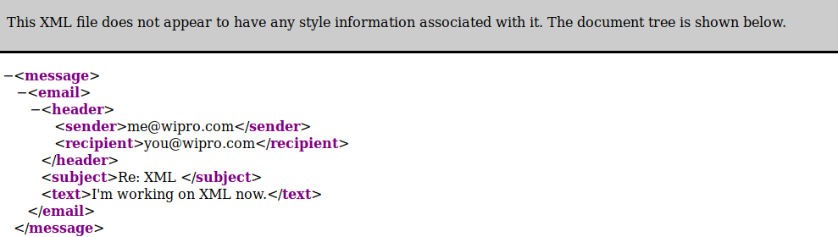

Result:
Hence we successfully solved above probleem and the output verified
Ex no: 15 | Creating XML document for given data
Date : | Creating XML document for given data

Question:3
Develop DTD for the below given XML document: <address> <name>Manju</name> <company>Wipro</company> <phone>9988776655</phone> </address>

Aim:
To Develop DTD for the below given XML document: <address> <name>Manju</name> <company>Wipro</company> <phone>9988776655</phone> </address>

Code:
<?xml version="1.0"?>
<!DOCTYPE note [
<!ELEMENT address (name,company,phone)>
<!ELEMENT name (#PCDATA)>
<!ELEMENT company (#PCDATA)>
<!ELEMENT phone (#PCDATA)>
]>
<address>
<name>Manju</name>
<company>Wipro</company>
<phone>"9092191952"</phone>
</address>
Output:

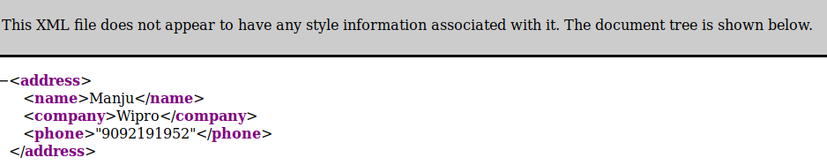

Result:
Hence we successfully solved above probleem and the output verified
Ex no: 16 | Develop a DTD file for given XML document
Date : | Develop a DTD file for given XML document

Question:1
Develop DTD file for the below given XML document:
<?xml version="1.0"?>
<?xml-stylesheet href="catalog.xsl" type="text/xsl"?>
<!DOCTYPE catalog SYSTEM "catalog.dtd">
<catalog>
<product description="Cardigan Sweater" product_image="cardigan.jpg">
<catalog_item gender="Men's">
<item_number>QWZ5671</item_number>
<price>39.95</price>
<size description="Medium">
<color_swatch image="red_cardigan.jpg">Red</color_swatch>
<color_swatch image="burgundy_cardigan.jpg">Burgundy</color_swatch>
</size>
<size description="Large">
<color_swatch image="red_cardigan.jpg">Red</color_swatch>
<color_swatch image="burgundy_cardigan.jpg">Burgundy</color_swatch>
</size>
</catalog_item>
<catalog_item gender="Women's">
<item_number>RRX9856</item_number>
<price>42.50</price>
<size description="Small">
<color_swatch image="red_cardigan.jpg">Red</color_swatch>
<color_swatch image="navy_cardigan.jpg">Navy</color_swatch>
<color_swatch image="burgundy_cardigan.jpg">Burgundy</color_swatch>
</size>
<size description="Medium">
<color_swatch image="red_cardigan.jpg">Red</color_swatch>
<color_swatch image="navy_cardigan.jpg">Navy</color_swatch>
<color_swatch image="burgundy_cardigan.jpg">Burgundy</color_swatch>
<color_swatch image="black_cardigan.jpg">Black</color_swatch>
</size>
<size description="Large">
<color_swatch image="navy_cardigan.jpg">Navy</color_swatch>
<color_swatch image="black_cardigan.jpg">Black</color_swatch>
</size>
<size description="Extra Large">
<color_swatch image="burgundy_cardigan.jpg">Burgundy</color_swatch>
<color_swatch image="black_cardigan.jpg">Black</color_swatch>
</size>
</catalog_item>
</product>
</catalog>

Aim:
To Develop DTD file for the above given XML document:

Code:
<<?xml version="1.0" encoding="UTF-8"?>
<?xml-stylesheet href="4.xsl" type="text/xsl"?>
<!DOCTYPE catalog SYSTEM "4.dtd">

<catalog>
<product description="Cardigan Sweater" product_image="cardigan.jpg">

<catalog_item gender="Men's">
<item_number>QWZ5671</item_number>
<price>39.95</price>
<size description="Medium">
<color_swatch image="rose-blue-flower-rose-blooms-67636.jpg">Red</color_swatch>
<color_swatch image="burgundy_cardigan.jpg">Burgundy</color_swatch>
</size>

<size description="Large">
<color_swatch image="red_cardigan.jpg">Red</color_swatch>
<color_swatch image="burgundy_cardigan.jpg">Burgundy</color_swatch>
</size>
</catalog_item>

<catalog_item gender="Women's">

<item_number>RRX9856</item_number>
<price>42.50</price>
<size description="Small">
<color_swatch image="red_cardigan.jpg">Red</color_swatch>
<color_swatch image="navy_cardigan.jpg">Navy</color_swatch>
<color_swatch image="burgundy_cardigan.jpg">Burgundy</color_swatch>
</size>

<size description="Medium">
<color_swatch image="red_cardigan.jpg">Red</color_swatch>
<color_swatch image="navy_cardigan.jpg">Navy</color_swatch>
<color_swatch image="burgundy_cardigan.jpg">Burgundy</color_swatch>
<color_swatch image="black_cardigan.jpg">Black</color_swatch>
</size>

<size description="Large">
<color_swatch image="navy_cardigan.jpg">Navy</color_swatch>
<color_swatch image="black_cardigan.jpg">Black</color_swatch>
</size>

<size description="Extra Large">
<color_swatch image="burgundy_cardigan.jpg">Burgundy</color_swatch>
<color_swatch image="black_cardigan.jpg">Black</color_swatch>
</size>

</catalog_item>
</product>
</catalog>

Output

Result:
Hence we successfully solved above probleem and the output verified

Ex no: 16 | Develop a DTD file for given XML document
Date : | Develop a DTD file for given XML document

Question:2
Develop an XML file following the DTD file given below:
<!DOCTYPE TVSCHEDULE [
<!ELEMENT TVSCHEDULE (CHANNEL+)>
<!ELEMENT CHANNEL (BANNER,DAY+)>
<!ELEMENT BANNER (#PCDATA)>
<!ELEMENT DAY (DATE,(HOLIDAY|PROGRAMSLOT+)+)>
<!ELEMENT HOLIDAY (#PCDATA)>
<!ELEMENT DATE (#PCDATA)>
<!ELEMENT PROGRAMSLOT (TIME,TITLE,DESCRIPTION?)>
<!ELEMENT TIME (#PCDATA)>
<!ELEMENT TITLE (#PCDATA)>
<!ELEMENT DESCRIPTION (#PCDATA)>
<!ATTLIST TVSCHEDULE NAME CDATA #REQUIRED>
<!ATTLIST CHANNEL CHAN CDATA #REQUIRED>
<!ATTLIST PROGRAMSLOT VTR CDATA #IMPLIED>
<!ATTLIST TITLE RATING CDATA #IMPLIED>
<!ATTLIST TITLE LANGUAGE CDATA #IMPLIED>
]>
Aim:
To Develop an XML file following the DTD file given above

Code:
<?xml version="1.0"?>
<!DOCTYPE TVSCHEDULE [
<!ELEMENT TVSCHEDULE (CHANNEL+)>
<!ELEMENT CHANNEL (BANNER,DAY+)>
<!ELEMENT BANNER (#PCDATA)>
<!ELEMENT DAY (DATE,(HOLIDAY|PROGRAMSLOT+)+)>
<!ELEMENT HOLIDAY (#PCDATA)>
<!ELEMENT DATE (#PCDATA)>
<!ELEMENT PROGRAMSLOT (TIME,TITLE,DESCRIPTION?)>
<!ELEMENT TIME (#PCDATA)>
<!ELEMENT TITLE (#PCDATA)>
<!ELEMENT DESCRIPTION (#PCDATA)>
<!ATTLIST TVSCHEDULE NAME CDATA #REQUIRED>
<!ATTLIST CHANNEL CHAN CDATA #REQUIRED>
<!ATTLIST PROGRAMSLOT VTR CDATA #IMPLIED>
<!ATTLIST TITLE RATING CDATA #IMPLIED>
<!ATTLIST TITLE LANGUAGE CDATA #IMPLIED>
]>

<TVSCHEDULE NAME="vehicle launch">
<CHANNEL CHAN="111">
<BANNER> APACHE </BANNER>
<DAY>
<DATE>11/12/2019</DATE>
<HOLIDAY> YES </HOLIDAY>
<PROGRAMSLOT VTR="333">
<TIME RATING="7.9">10:35a.m</TIME>
<TITLE LANGUAGE="english"> HAHAHAH </TITLE>
<DESCRIPTION > BIKE REVIEWS </DESCRIPTION>
</PROGRAMSLOT>
</DAY>
</CHANNEL>
</TVSCHEDULE>
Output

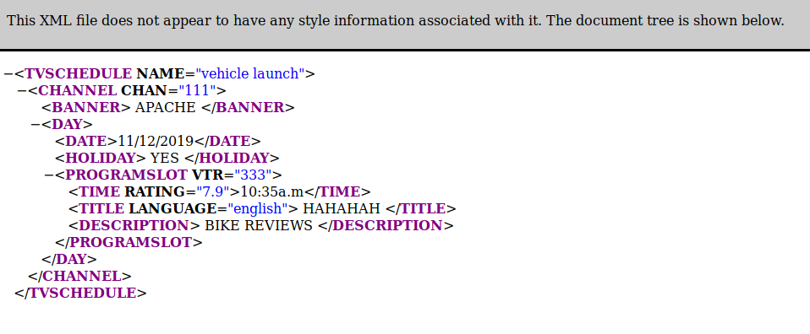

Result:
Hence we successfully solved above probleem and the output verified
Ex no: 17 | Developing a XML document to avoid Naming conflits
Date : | Developing a XML document to avoid Naming conflits

Question:1
Avoid Naming conflict in the following XML document:
<Phone>
<name>Moto E</name>
<ModelNo>123</ModelNo>
<Processor> Qualcomm Snapdragon 200 </Processor>
<Battery>2390 mAh</Battery>
</Phone>
<Phone>
<name>Beetel M71 Landline</name>
<ModelNo>456</ModelNo>
<Display>LCD Screen</Display>
<Corded>Yes</Corded>
</Phone>

Aim:
To Avoid Naming conflict in the above XML document:

Code:
<?xml version="1.0" encoding="UTF-8"?>
<Phone>
<s1:mobile xmlns:s1 = "www.google.com">
<s1:name>Moto E</s1:name>
<s1:ModelNo>123</s1:ModelNo>
<s1:Processor> Qualcomm Snapdragon 200 </s1:Processor>
<s1:Battery>2390 mAh</s1:Battery>
</s1:mobile>
<s2:mobile1 xmlns:s2 = "www.google.com">
<s2:name>Beetel M71 Landline</s2:name>
<s2:ModelNo>456</s2:ModelNo>
<s2:Display>LCD Screen</s2:Display>
<s2:Corded>Yes</s2:Corded>
</s2:mobile1>
</Phone>

Output

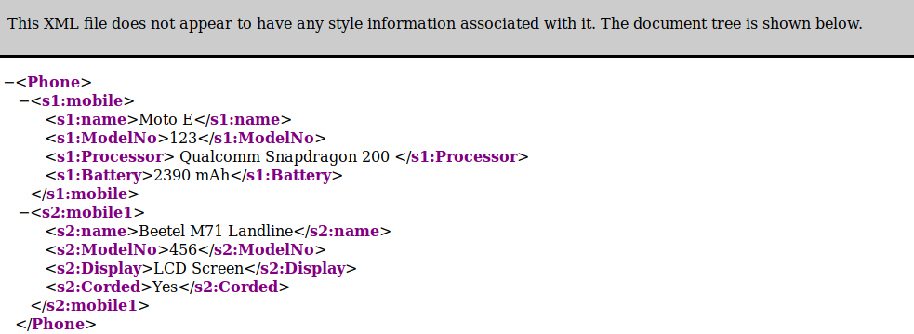

Result:
Hence we successfully solved above probleem and the output verified
Ex no: 18 | Develop a Schema file for a given XML file
Date : | Develop a Schema file for a given XML file

Question:1
Create and XSD file for the XML document given in the DTD

Aim:
To Create and XSD file for the XML document given in the DTD

Code:
<?xml version="1.0" ?>
<xs:schema xmlns:xs="http://www.w3.org/20001/XMLSchema.com">
<xs:element name="StudentRegistrationForm">
<xs:complexType>
<xs:sequence>
<xs:element name="name" type="xs:string"/>
<xs:element name="age" type="xs:int"/>
<xs:element name="Gender" type="xs:string"/>
<xs:element name="Course" type="xs:string"/>
</xs:sequence>
</xs:complexType>
</xs:element>
</xs:schema>
Output:

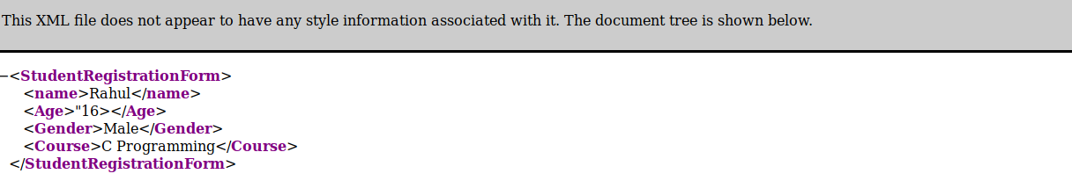

Result:
Hence we successfully solved above probleem and the output verified
Ex no: 18 | Develop a Schema file for a given XML file
Date : | Develop a Schema file for a given XML file

Question:2
Create an XSD file for the XML document given in the DTD

Aim:
To Create an XSD file for the XML document given in the DTD

Code:
<?xml version="1.0" ?>
<xs:schema xmlns:xs="http://www.w3.org/20001/XMLSchema.com">
<xs:element name="message">
<xs:complexType>
<xs:sequence>
<xs:element name="email">
<xs:complexType>
<xs:sequence>
<xs:element name="sender" type="xs:string"/>
<xs:element name="recipient" type="xs:string"/>
</xs:sequence>
</xs:complexType>
</xs:element>
<xs:element name="subject" type="xs:string"/>
<xs:element name="text" type="xs:string"/>
</xs:sequence>
</xs:complexType>
</xs:element>
</xs:schema>
Output:
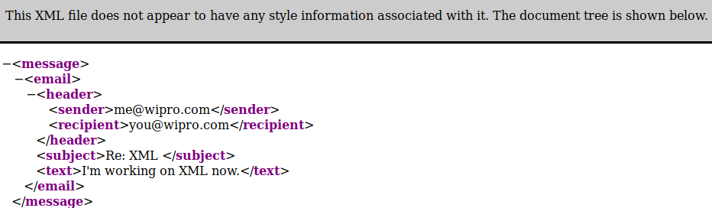
Result:
Hence we successfully solved above probleem and the output verified
Ex no: 19 | Develop a webpage using Flask with HTML
Date : | Develop a webpage using Flask with HTML

Question:1
Design the following web page using Flask with HTML and render it for the route ‘/details’
Aim::
To Design the following web page using Flask with HTML and render it for the route ‘/details’
Code:
from flask import Flask, render_template
app = Flask(__name__)

@app.route('/')
def main():
return render_template('hello.html')
if __name__ == '__main__':
app.run(debug = True)
HELLO.HTML:
<!DOCTYPE html>
<html lang="en">
<head>
<meta charset="utf-8">
<title>Say hello</title>
</head>
<body>
<form>

<p> Title<select ><option value="volvo">Mr</option>
<option value="saab">Mrs</option></select></p>

<p>Name <input type='text' placeholder='Name'></p>
<p>City <input type='text' placeholder='City'></p>
<p>Country <input type='text' placeholder='Country'></p>
<p>Telephone <input type='text' placeholder='Telephone'></p>

<p>Please Inform us of your interest</p>
<input type="checkbox" name="vehicle1" value="Bike">Sports<br>
<input type="checkbox" name="vehicle2" value="Car">Music<br>
<input type="checkbox" name="vehicle3" value="Boat" >reading<br>
<input type="checkbox" name="vehicle3" value="Boat">Tv and Flim<br>

<p>Your Age</p>
<input type="radio" name="gender" value="male" checked>Less Than 25
<input type="radio" name="gender" value="female">26-40
<input type="radio" name="gender" value="other">41-65
<input type="radio" name="gender" value="other1">Over 65<br><br>
<input type="submit" value="submit">
</body>
</html>

Output

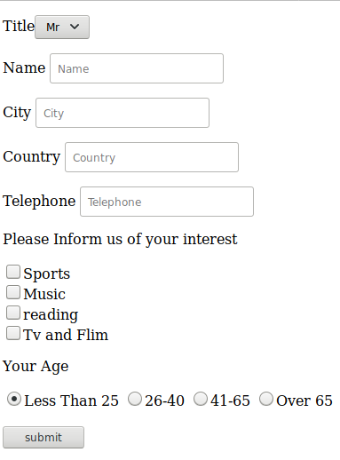

Result:
Hence we successfully solved above probleem and the output verified
Ex no: 19 | Develop a webpage using Flask with HTML
Date : | Develop a webpage using Flask with HTML

Question:2
Develop a web application using Flask based on the following routes:

/hello/ | Return the message “Good Morning!”

Aim:
To Develop a web application using Flask based on the following routes:

Code:
from flask import Flask
app = Flask(__name__)
@app.route('/hello/')
def hello():
return 'Good Morning !'
@app.route('/hello/<name>')
def hello1(name):
return '<h1>Good Morning! %s</h1>' %name
if __name__ == '__main__':
app.run(debug=True)

Output

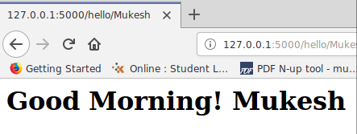

Result:
Hence we successfully solved above probleem and the output verified
Ex no: 20 | Develop a webpage using Flask with HTML
Date : | Develop a webpage using Flask with HTML

Question:1
Design the following web page using Flask

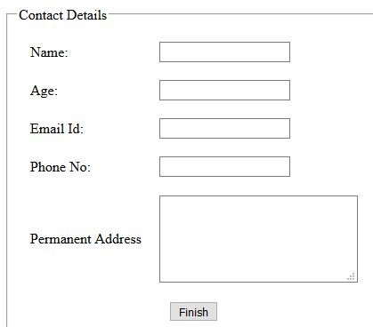

Aim:
To Design the following web page using Flask

Code:
from flask import *
app = Flask(__name__)
app.secret_key = "mukesh"

@app.route('/')
def home():
return render_template("home.html")

@app.route('/login')
def login():
return render_template("login.html")

@app.route('/success',methods = ["POST"])
def success():
if request.method == "POST":
session['name1']=request.form['name1']
session['age']=request.form['age']
session['email']=request.form['email']
session['pn']=request.form['pn']
session['pa']=request.form['pa']
return render_template('success.html')
@app.route('/profile')
def profile():
name1=session['name1']
age=session['age']
email=session['email']
pn=session['pn']
pa=session['pa']
return render_template('profile.html',a=name1,b=age,c=email,d=pn,e=pa)
if __name__ == '__main__':
app.run(debug = True)
Output:

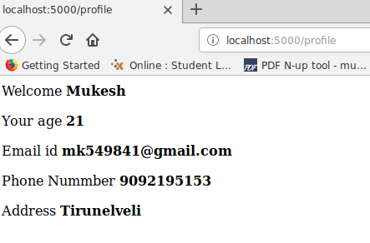

Result:
Hence we successfully solved above probleem and the output verified

Ex no: 20 | Develop a webpage using Flask with HTML
Date : | Develop a webpage using Flask with HTML

Question:2
Write a JavaScript function to remove specified number of characters from a string

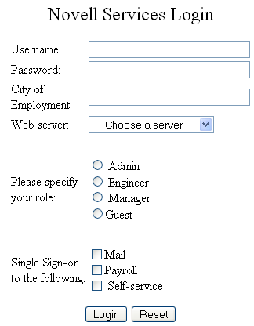

Aim:
Design the HTML form given below and render it for the route ‘/services’

Code:
from flask import Flask, render_template
app = Flask(__name__)

@app.route('/')
def main():
return render_template('hello1.html')
if __name__ == '__main__':
app.run(debug = True)
HELLO.HTML:
<!DOCTYPE html>
<html lang="en">
<head>
<meta charset="utf-8">
<title>Say hello</title>
</head>
<body>
<form>

<p> Title<select ><option value="volvo">Mr</option>
<option value="saab">Mrs</option></select></p>
<p>Name <input type='text' placeholder='Name'></p>
<p>City <input type='text' placeholder='City'></p>
<p>Country <input type='text' placeholder='Country'></p>
<p>Telephone <input type='text' placeholder='Telephone'></p>
<p>Please Inform us of your interest</p>
<input type="checkbox" name="vehicle1" value="Bike">Sports<br>
<input type="checkbox" name="vehicle2" value="Car">Music<br>
<input type="checkbox" name="vehicle3" value="Boat" >reading<br>
<input type="checkbox" name="vehicle3" value="Boat">Tv and Flim<br>
<p>Your Age</p>
<input type="radio" name="gender" value="male" checked>Less Than 25
<input type="radio" name="gender" value="female">26-40
<input type="radio" name="gender" value="other">41-65
<input type="radio" name="gender" value="other1">Over 65<br><br>
<input type="submit" value="submit">
</body>
</html>
Output:

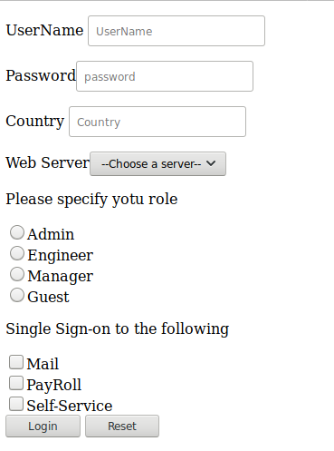

Result:
Hence we successfully solved above probleem and the output verified
Ex no: 21 | Desingn the given webpage using macros in jinga
Date : | Desingn the given webpage using macros in jinga

Question:1
Create a webpage to print your name on the screen with every letter having a different heading size.
(ii)Create a webpage that prints two lists with any information you want. One list should be an ordered list and the other list should be an unordered list
(iii)Create a webpage that will display an image that has a border of size 2, a width of 200px, and a height of 200px.
(iV)Develop a webpage to display the table having the columns (highlighted) as Decimal, English, Spanish, Korean, and Binary. Following are the data to be in each rows respective of their columns :
Aim:
To Create an HTML page with flask with above condition

Code:
from flask import Flask,render_template
from flask import *
app=Flask(__name__)

app.secret_key = "mukesh"

@app.route('/')
def login():
return render_template("login.html")

@app.route('/success',methods = ["POST"])
def success():
if request.method == "POST":
session['name1']=request.form['name1']
session['tele']=request.form['tele']
session['email']=request.form['email']
session['age']=request.form['age']
session['gender']=request.form['gender']
session['box']=request.form['box']
return render_template('success.html')
@app.route('/profile')
def profile():
name1=session['name1']
tele=session['tele']
email=session['email']
age=session['age']
gender=session['gender']
box=session['box']

return render_template('indexpage.html',a=name1,b=tele,c=email,d=age,e=gender,f=box)
if __name__ == '__main__':
app.run(debug=True)
INDEX.HTML:
{% from "sample.html" import w1 %}
{% from "sample.html" import w2 %}
{% from "sample.html" import w3 %}
{% from "sample.html" import w4 %}
{% from "sample.html" import w5 %}
{% from "sample.html" import w6 %}
<!DOCTYPE html>
<html>
<head>
</head>
<body>
{{w1(a)}}
{{w2(b)}}
{{w3(c)}}
{{w4(d)}}
{{w5(e)}}
{{w6(f)}}
</body>
</html>
Output:
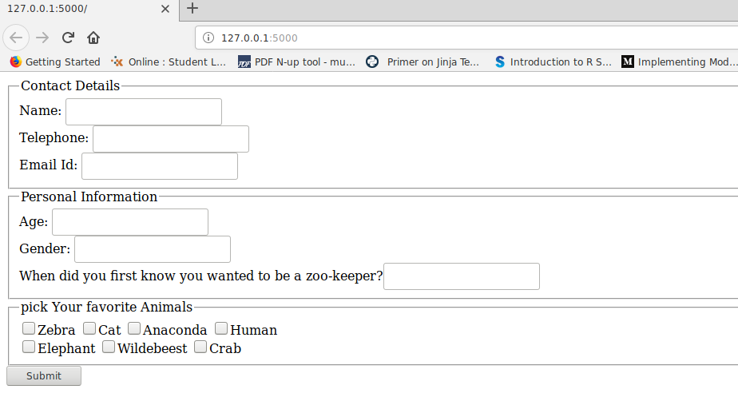

Result:
Hence we successfully solved above probleem and the output verified
Ex no: 22 | Design the webpage using template inheritance
Date : | Design the webpage using template inheritance

Question:1
Design a website for Ace Car Company based on the layout shown in figure [use template inheritance]:
- Header.html – the header must contain the name of the company and a logo at the left.
- Home.html – should contain a brief description about the company.
- Cars.html – should contain a table describing at least 5 car details
- Contact.html – should contain the address, phone number, fax and email id of the company.
- Footer.html – the footer must contain a copyright information of the company.
Aim:
To Design a web page using a template inheritance

Code:
from flask import Flask, render_template
app = Flask(__name__)
@app.route("/")
def template_test():
return render_template('header.html')
@app.route("/1")
def template_test1():
return render_template('home1.html')
@app.route("/2")
def template_test2():
return render_template('footer.html')
app.run(debug=True)
Header.html
{% extends "home.html" %}
{% block content %}

<!DOCTYPE html>
<html>
<head>
</head>
<body
{% endblock %}
</body>
</html>

footer.html
{% extends "contact.html" %}
{% block content %}
<footer>
<small>&copy; Copyright 2018, Example Corporation</small>
</footer>
{% endblock %}

Output:

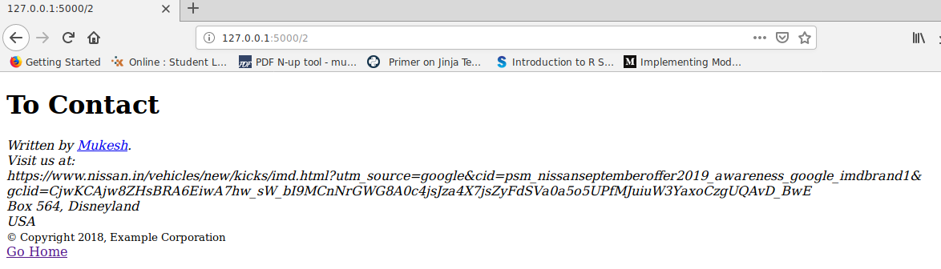

Result:
Hence we successfully solved above probleem and the output verified

